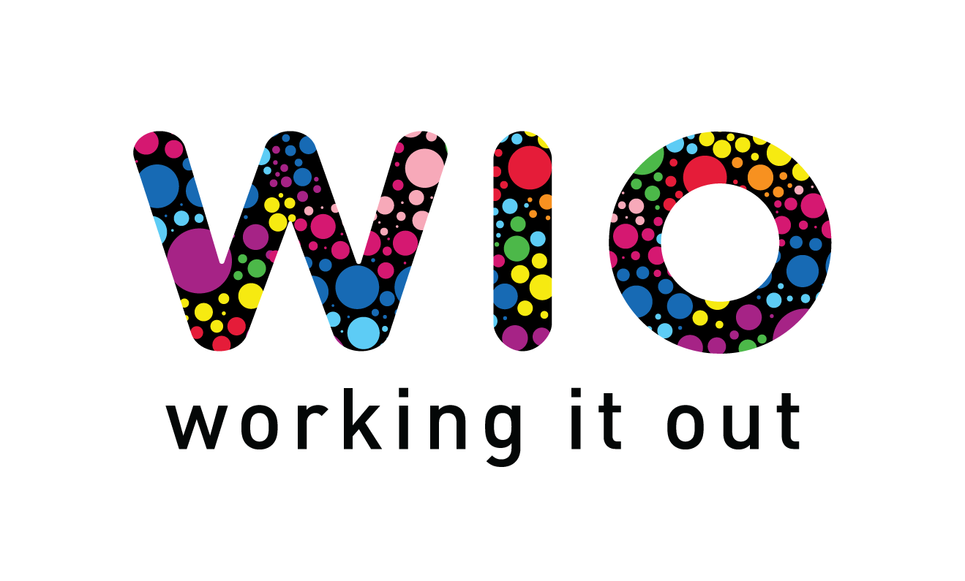

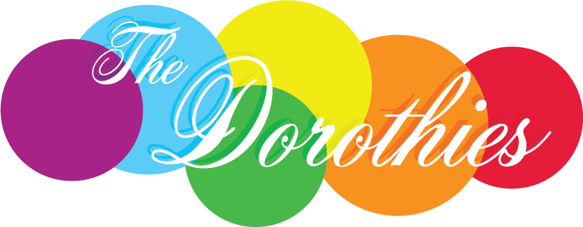

The 2024 Dorothies Awards
Celebrating LGBTIQA+ inclusive practice in Tasmanian Government Agencies/Departments
Nomination Form

Nominations close 5pm Friday 3rd May, 2024

Nominee
Agency / Department Name:
Nominator Information
Contact person:
Role:
Email:
Phone:

Referee 1 (preferably an active member of the agency/department or community)
Name:
Role:
Phone:
Email:
Relationship to nominee:

Referee 2 (Optional)
Name:
Role :
Phone:
Email:
Relationship to nominee:

Nomination Statement – tell us why the nominee should win.
What has the agency/department done to support LGBTIQA+ inclusion? Include any changes to culture, policies and procedures, activities, events, media, visibility, advocacy, attitudes, and learning (maximum of 500 words).

How long and where has the agency/department been involved in promoting LGBTIQA+ inclusion? (maximum 150 words)

Who has benefited and how? (maximum 300 words)

Anything else you would like to tell us? (maximum 200 words)

Do you have other supporting materials you would like to include (photos, media, documents etc). Please send as attachments with this form.

Yes No

