

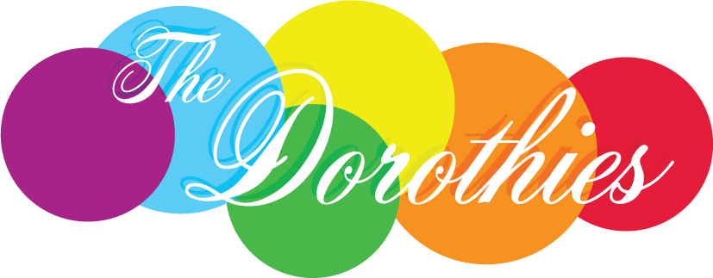

The 2025 Dorothies Awards
Celebrating LGBTIQA+ Inclusion in Tasmanian Workplaces
Nomination Form

Nominations close 5pm Friday 2nd May, 2025

Nominee
Workplace Name:
Nominator Information
Contact person:
Role:
Email:
Phone:

Referee 1 (preferably an active member of the nominated workplace)
Name:
Role:
Phone:
Email:
Relationship to nominee:

Referee 2 (Optional)
Name:
Role :
Phone:
Email:
Relationship to nominee:

Nomination Statement – tell us why the nominee should win.
What has the workplace done to support LGBTIQA+ inclusion for workers and their families? Include any changes to culture, policies and procedures, activities, events, media, visibility, advocacy, attitudes, and learning. (maximum of 500 words)

How and for how long has the workplace been involved in promoting LGBTIQA+ inclusion for employees and their families? In other words, demonstrate your commitment over time. (maximum 150 words)

Who has benefited and how? (maximum 300 words)

Anything else you would like to tell us? (maximum 200 words)

Do you have other supporting materials you would like to include (photos, media, documents etc). Please send as attachments with this form.

Yes No

